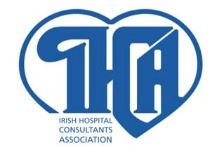
IRISH HOSPITAL CONSULTANTS ASSOCIATION
HERITAGE HOUSE  DUNDRUM OFFICE PARK DUBLIN 14 | TELEPHONE 298 9123  FAX 298 9395  EMAIL info@ihca.ie  WEB www.ihca.ie

12th October 2012
PRESS RELEASE

IHCA Statement on the HSE Referral of the LRC Proposals to the Labour Court

The IHCA is surveying its members to ascertain their views on the proposals set out by the Labour Relations Commission on 17th September. That process, to be concluded in a short number of weeks, will determine the level of support for the proposals and the outcome will then be advised to the HSE.

It appears to the Association that the HSE is being most unhelpful by now referring the proposals to the Labour Court for a recommendation where no disagreement has yet been identified on the proposals. This is most regrettable and cannot be in the best interests of patients or taxpayers.

Consultant members of the Association have been working well beyond their contract hours, implementing and delivering widespread changes under Croke Park over the past number of years. The HSE appears intent on jeopardising that good work with its current approach to reform.

Ends

For further information contact:

Mr. Martin Varley,
Secretary General.

Tel: 01- 2989123
Mobile: (087) 2274099

